- Purpose
This Work Instruction details the process for integrating ReportRighter into your document templates.
- Parent Documents

Document Number | Title
SOP5001 | ReportRighter

- Child Documents

Document Number | Title
VA5001 | ReportRighter Tutorial

- Responsibility
  - It is the responsibility of the Software Validation Engineer to ensure that all documentation relating to the use and validation of ReportRighter is up to date and correct.
- Creating Import Locations
  - While creating a document template be sure to use unique text for each area that will be replaced with data. This text should be descriptive of what will be imported into this location and unique so that it will not be somewhere in the report that should not be replaced. For example:
    - If there is a section where validation results will be imported, do not type validation results type something unique like [validation results] or {validation results}.
    - TIP: It is a good idea to create a standardized way of identifying areas where data will be imported such as surrounding the text with brackets and bolding: [validation results]. This will make it easier to identify unintentional import areas.
  - Highlight(select) the first area of unique text and click the Insert Cell Import button to convert it into a cell import. If it is a location where an Excel shape will be imported, click the Insert Shape Button instead. Repeat this for each string of text that is to be replaced with data.
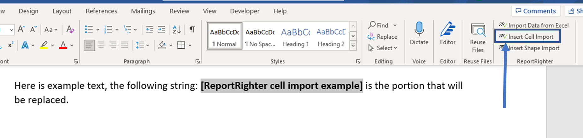
Figure 1. Insert a cell import
    - TIP: ReportRighter searches and replaces all instances of the highlighted text within the document with a cell import when the Insert Cell Import button is clicked. All of these areas will import the same data.
- Saving Import Settings
  - After all of the unique strings have been converted into import locations click the Import Data from Excel button.
  - The ReportRighter task pane contains three main components: the header(1), the cell import settings(2), and the shape import settings(3).
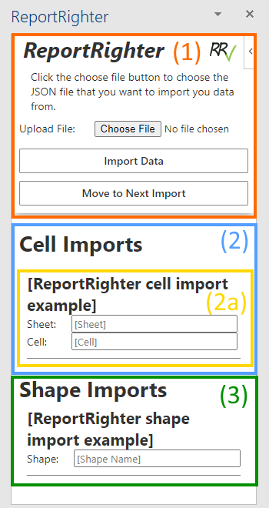
Figure 2. ReportRighter task pane in Word
  - The cell import settings section, section (2), contains setting cards(2a) which contain two text inputs: a sheet input, and a cell input. Type the name of the sheet which you will be importing the data from in the sheet input and the cell address (e.g., A1).
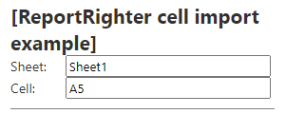
Figure 3. Cell import settings card
  - The shape import settings section, section (3), also contains setting cards but these only include one text input for the shape name. The shape name can be found in Excel by clicking on the desired shape and looking at the address box in the upper left-hand corner. Figure 2.
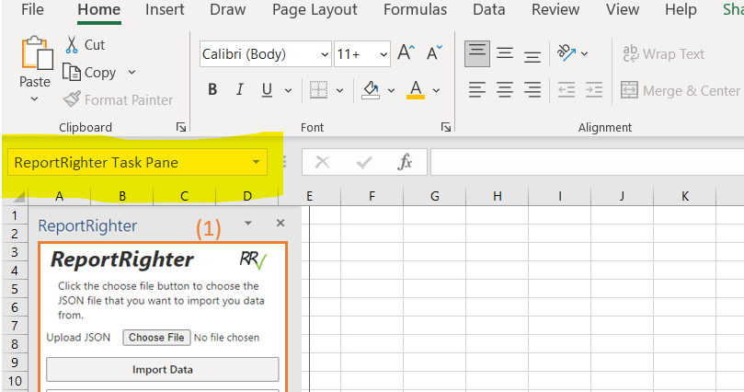
Figure 4. Shape name in Excel
  - After entering the import settings for all cell and shape imports save the word document, these settings will be saved with the document.
- Importing Data from Excel
  - In the Excel workbook that contains the data to be imported. Click the Compile Workbook button in the upper right corner of the home tab. When the ReportRighter task pane opens and displays a message confirming that the workbook has been successfully compiled, save the workbook and close it.
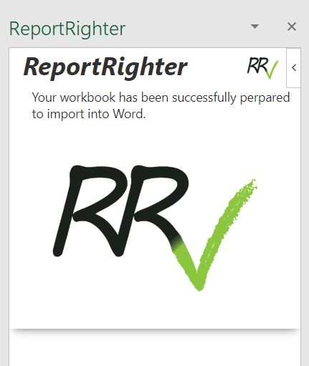
Figure 5. ReportRighter task pane in Excel
  - In the document template that you will be importing the data into click the Import Data from Excel button. When the ReportRighter task pane opens click the Choose File button, this will open up a fie explorer dialog, use this to find and select the workbook containing the data.
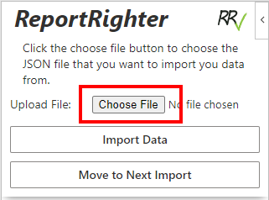
Figure 6. Choose File button
  - After the workbook has been selected click the Import Data button in the header; ReportRighter will begin importing the data.
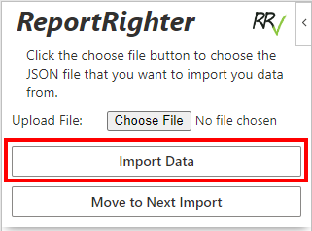
Figure 7. Import Data button
  - When ReportRighter has finished importing all of the data, any cells that did not have a value, cells that were empty, will be highlighted in yellow.
    - Note: Import locations will not be highlighted if the specified sheet was not found. This allows the user to import data from multiple workbooks.
  - It is optional but a good idea to double check to make sure that all of the data was imported correctly, sometimes cell addresses can be entered wrong when setting up the document. Use the Move to Next Import button in the ReportRighter task pane header to index through the import locations.
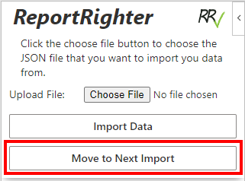
Figure 8. Move to Next Import button

